Dedicated Server

🖥️ What is a Dedicated Server?
# Source: Chatgpt (GPT-5-Mini) at [1/16/2026]
A Dedicated Server is a physical server that is completely reserved for one customer or organization. It is not shared with anyone else — all of its hardware (CPU, RAM, storage, etc.) is fully dedicated to your use.
✅ 100% of the server's resources belong to you — unlike shared hosting or VPS where resources are split.

🔧 What Makes It "Dedicated"?
# Source: Chatgpt (GPT-5-Mini) at [1/16/2026]
Feature | Dedicated Server
🔒 Exclusive use | Only one customer uses it
🧠 Full control | You can install any OS, app, or config
📦 Fixed hardware | Specific specs (RAM, CPU, disk) allocated to you
🌐 Usually hosted | In a data center or cloud provider facility

🧑‍💻 Who Uses Dedicated Servers?
# Source: Chatgpt (GPT-5-Mini) at [1/16/2026]
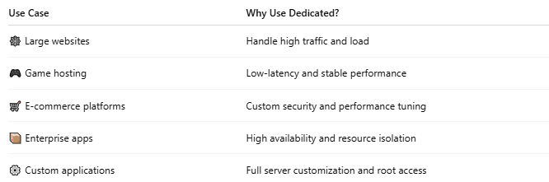

Use Case | Why Use Dedicated?
🕸️ Large websites | Handle high traffic and load
🎮 Game hosting | Low-latency and stable performance
🛒 E-commerce platforms | Custom security and performance tuning
📦 Enterprise apps | High availability and resource isolation
⚙️ Custom applications | Full server customization and root access

🆚 Dedicated Server vs Other Hosting Types
# Source: Chatgpt (GPT-5-Mini) at [1/16/2026]
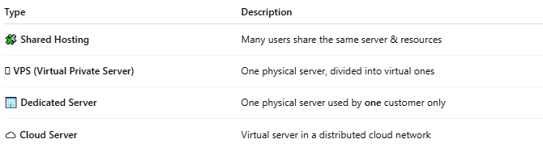

Type | Description
🧩 Shared Hosting | Many users share the same server & resources
🪟 VPS (Virtual Private Server) | One physical server, divided into virtual ones
🏢 Dedicated Server | One physical server used by one customer only
☁️ Cloud Server | Virtual server in a distributed cloud network

✅ Pros and Cons
# Source: Chatgpt (GPT-5-Mini) at [1/16/2026]
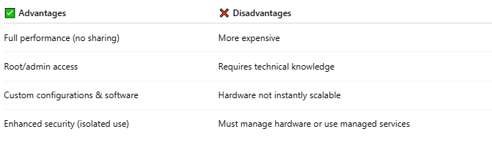

✅ Advantages | ❌ Disadvantages
Full performance (no sharing) | More expensive
Root/admin access | Requires technical knowledge
Custom configurations & software | Hardware not instantly scalable
Enhanced security (isolated use) | Must manage hardware or use managed services

📌 Summary
# Source: Chatgpt (GPT-5-Mini) at [1/16/2026]

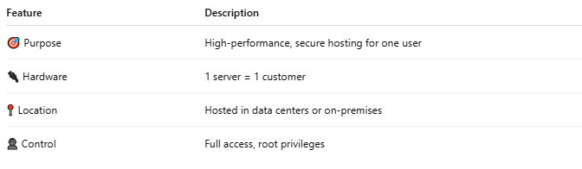

Feature | Description
🎯 Purpose | High-performance, secure hosting for one user
🔌 Hardware | 1 server = 1 customer
📍 Location | Hosted in data centers or on-premises
👤 Control | Full access, root privileges

Would you like:
- 🔄 A comparison between Dedicated Server vs VPS vs Cloud?
- 🖥️ Help setting up a dedicated server for web or game hosting?
- 💰 An overview of cost considerations and providers?

